Report of the mid-term project:
Visual Equalizer Synchronized with Audio
Using Computer Vision and Audio Signal Processing.
Authors: Alejandro Garcia Castro, Samuel Riaño Patiño.
Introduction
This project encouraged me to look for a way to make an image react to a song, so it would look like a real visual equalizer, the kind that can be seen in some music players or in concerts, that moves and changes color depending on the music. A program like this needs two things that normally are treated separately, an audio analysis part, that has to find out how strong the bass, the mids and the highs are at every moment, and also when a beat happens, and an image processing part, that has to take that information and actually change how the image looks, frame by frame, until it becomes a video.
Although the final result is only a short video of 20 seconds, the same idea is behind things that are used everyday, like the equalizer bars of Spotify or YouTube Music, or the visuals that are projected in a concert following the rhythm of the song, so it was interesting to build a simple version of that from scratch, using only classical signal processing and computer vision, without needing any trained model.
General objective
- To catch on how an audio signal and image process techniques can be analyzed and combined, to generate a video that reacts visually to the music.
Specific objectives
- To master how to extract frequency and rhythm information from a song using spectral analysis techniques, such as the mel spectrogram and the onset detection.
- To apply image processing concepts, like dividing an image in regions and modifying the brightness and the zoom of each one, as part of the pipeline that builds the final video.
Methodology
The program was developed in python, using “librosa” for the audio analysis, OpenCV (cv2) for everything related with the image and the video, “numpy” for the matrix operations and matplotlib to generate a figure with the internal signals of the program, this in order to be able to show in this report how the audio was being transformed step by step. The image and the song that were used are the same ones that were provided for this project, and “ffmpeg” was used at the end, outside of python, to join the silent video with the original audio.
The “shutil” and subprocess libraries are used to check if “ffmpeg” is installed in the computer and so it can be run from python in order to join the video with the audio, cv2 (OpenCV) is the one in charge of everything related with the images and the video writing, that means, reading them, cropping them, changing the brightness and the zoom and finally saving every frame.”Librosa” is used for all the audio analysis, since this library allows to load the audio, get the energy of each frequency band and also detect the beats (onsets) of the song. matplotlib is used only to save a figure with the graphs of the audio analysis, this in order to include them in the report. “numpy” is used in almost the whole program because it works constantly with matrices and vectors, so it makes the math operations that are needed a lot easier. Finally, “pathlib” is used to handle in a more comfortable way the paths of the files that are going to be used and generated.
Before the functions, the program declares a lot of constants, that are in charge of defining the paths of the image and the audio, how long the video is going to last, how many fps it´s going to have, how many frequency bands are going to be analyzed and how the image is going to be divided in a grid, also the parameters that are used to smooth the animation are left there, and to control how strong the brightness, the zoom and the flash of every tile if the image changes.
The "cargar_audio" function simply uses librosa to load the audio file that is indicated, in mono and with a specific duration, this function also warns through console if the audio has less than 10 seconds, since the statement asked for the video to last between 10 and 20 seconds; "energias_por_banda" function receives the audio signal and calculates the mel spectrogram, that is basically the energy that the sound has in different frequency bands along the time, after that this energy is passed to decibels with the power_to_db function, since this way it´s easier to compare them, this function returns those energies together with the time that corresponds to each one.
As those energies come out in very different scales between each band, the "normalizar_bandas" function looks for the percentile 5 and 95 of each band to know more or less between what values it moves, and so it can bring all the values to a range between 0 and 1; to this a power (gamma) is applied so the small changes don't look as equal as the big changes.
The "suavizar_ataque_release" function is one of the most important of the program, since without it the video would look very rough, changing suddenly between one value and another, this function what it does is comparing each value with the previous one, if the current value is bigger it goes up faster (attack) and if it's smaller it goes down slower (release), this simulates how real sound equalizers work and it's used both for the frequency bands and for the beats of the song; "fuerza_de_golpes" function uses the librosa function called onset_strength, that basically detects in which moments there are strong beats in the song (like a kick or a cymbal), then those values are normalized dividing by the percentile 95, so the strongest beat of the song stays close to 1.; also "interpolar_a_video" function is needed because the audio and the video don't have the same amount of "samples" per second, so this function takes the data that comes from the audio and interpolates it so there is a value for every frame of the video, without this function the image couldn't be synchronized well with the sound.
Already in the image part, the "preparar_imagen" function reads the image with cv2 and crops it so it stays with the same proportion of the final video, this avoids the image to look deformed at the moment of resizing it; "cortar_tiles" function divides the image in a grid, in this case of 3 rows by 4 columns, so each one of those 12 pieces (tiles) corresponds to a different frequency band. So the bottom part of the image corresponds to the deepest sounds (low bands) and the top one to the sharpest, the "banda_a_tile" function is in charge of calculating in which row and column of the grid every band goes.
The "transformar_tile" function is the one that really gives the equalizer effect to each piece of the image, since according to the energy that band has in that moment, it goes the brightness up or down and also makes it a little zoom, also if in that instant there is a strong beat (flash) an extra brightness is added to all the tiles; "renderizar_frame" function simply joins everything before, it goes through the 12 bands, applies to each tile its corresponding transformation and joins them again in a single image, also adding a black border to each tile so they look more separated; "escribir_video" function is the one that goes frame by frame, calling renderizar_frame as many times as needed according to the amount of frames the video has, and it saves them with the cv2 VideoWriter; this function also prints every 100 frames so the progress can be seen, since this process can take quiet a while.
Since cv2 can't save the audio to the video, ffmpeg needs to be used outside, that's why the "buscar_ffmpeg" function looks if ffmpeg is already installed in the system, and if it doesn't find it there, it tries to find it with the imageio_ffmpeg library, that brings its own copy of ffmpeg. Also"unir_audio" function is the one that finally uses that ffmpeg to join the video without audio with the original audio file, cutting it so it stays with exactly the same duration of the video; if ffmpeg is not found, the program warns that the video is going to stay without audio but continues anyway.
Finally, the "guardar_figura" function has nothing to do with the video itself, this one is only used to generate an image with 4 graphs that show how the audio signal was transforming during the whole process (the raw energy, the normalized, the smoothed and the beats), this is useful to be able to show in the report how the program works internally.
In the "main()" first it's checked with an assert that the rows times the columns are equal to the amount of bands, and that the amount of bands and the fps are in a correct range, this so the program doesn't keep running if something is wrongly configured. After that cargar_audio is called and all the analysis explained before is done (energies, normalization, smoothing and beats), the figure is saved, the data is interpolated to the video, the image is prepared and the tiles are cut; finally escribir_video is called to generate the video without audio and unir_audio is called to add the sound, printing at the end the path where the video and the figure were saved.
Results
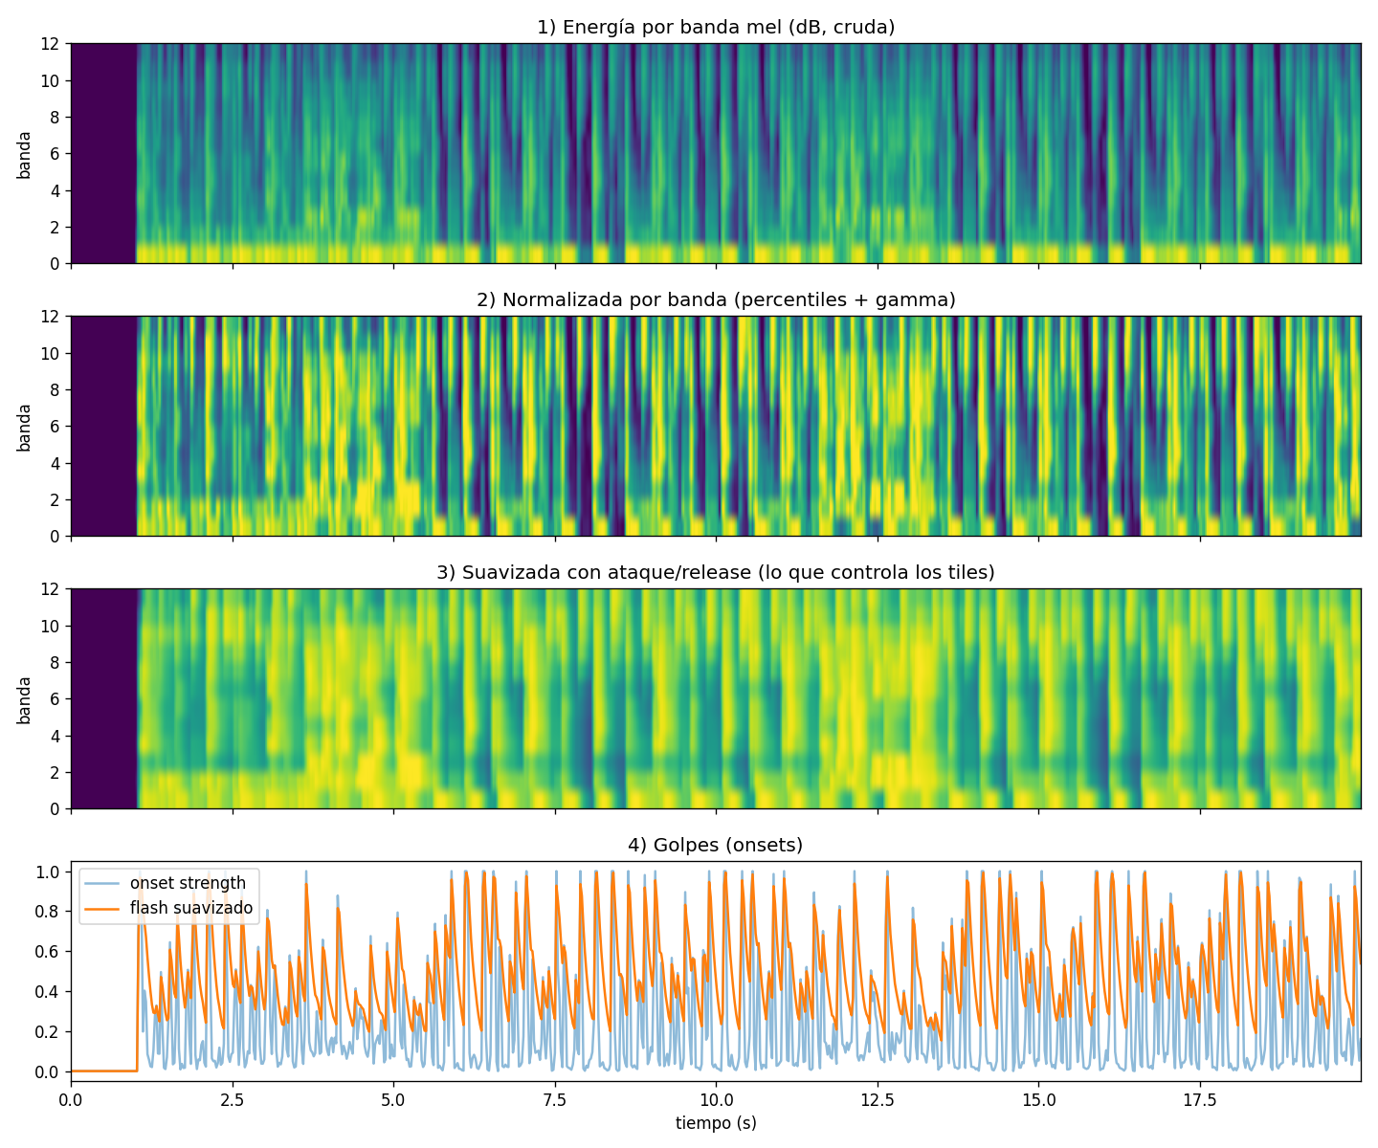
Image 1: Own elaboration.
In this image it can be seen the four stages that the audio signal goes through inside the program, first the raw energy of the mel bands, that looks pretty noisy, then the same energy already normalized between 0 and 1, after that the same information but smoothed with the attack and release, that is the one that really controls the tiles, and finally the onset strength together with the flash, where every peak matches with a beat of the song.
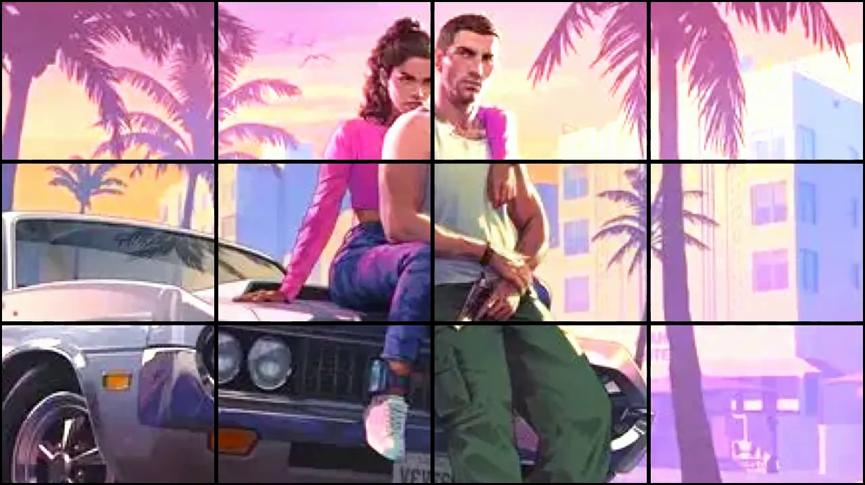
Image 2: Own elaboration, based on rockstar´s artwork.
Here it can be seen one single frame of the final video already divided in the 3x4 grid, in this exact moment the tiles with more energy in their band look brighter and a bit more zoomed than the others, and the black border that separates every tile can also be noticed, which was added so the grid effect looks clearer.
The complete 20 second video, together with this same figure, is attached along with this report.

We have gotten a video because of the whole process, that mixes the music short clip of the song “Off the Grid - !!! (Chk Chk Chk)”, that was selected because it was taken from the soundtrack of GTA VI, with an artwork of the same videogame that was created as a promotional poster. Even though Rockstar selected this song to be part of the videogame, we selected this song because its aura is perfectly connected with the picture.
Conclusion
- Although the program manages to make the image react to the music in a way that actually looks synchronized, the result depends a lot on parameters that were tuned by hand, like the attack and release times or the gamma of the normalization, so a different song, specially one with a different rhythm, would probably need those values to be adjusted again to look good.
- Working on this project was useful to actually see, and not only read about, how a mel spectrogram and an onset detector represent a song, since normally these are just numbers that are hard to imagine, but turning them into something visual, like the brightness of a tile, made a lot easier to understand what that information really means.

References

- Rockstar Games. (2023, December 1). Grand Theft Auto VI [Announcement artwork]. https://www.rockstargames.com/VI
- !!! (Chk Chk Chk), & Pace, M. (n.d.). Off the grid [Video]. YouTube. https://www.youtube.com/watch?v=QOqlTKP9T1s

Video

